EXPT NO 2 Configure VLANs and inter-VLAN routing in Packet Tracer
Objectives:
(i) To create and configure Virtual Local Area Networks (VLANs) for logical network segmentation and traffic isolation.
Software/Apparatus required:
(i) Cisco Packet Tracer
(ii) End Devices (PCs)
(iii) Switches
(iv) Copper Straight-through Cable / Automatic Cable Selector
(v) Routers
Procedure
Objective 1: VLAN Configuration
1. Open Cisco Packet Tracer.
2. Place two switches and six PCs in the workspace.
3. Connect the PCs to the switches using straight-through cables.
4. Connect the two switches using a crossover cable.
5. Create VLAN 10 and VLAN 20 on both switches.
6. Assign the ports connected to PC0, PC1, and PC2 to VLAN 10.
7. Assign the ports connected to PC3, PC4, and PC5 to VLAN 20.
8. Configure the link between the switches as a trunk link.
9. Configure the PCs with the required network settings.
10. Verify communication between devices belonging to the same VLAN.
11. Verify that communication between devices in different VLANs is not possible.
12. Save the configuration and observe the results.
Networking diagram:
Objective 1: VLAN Configuration
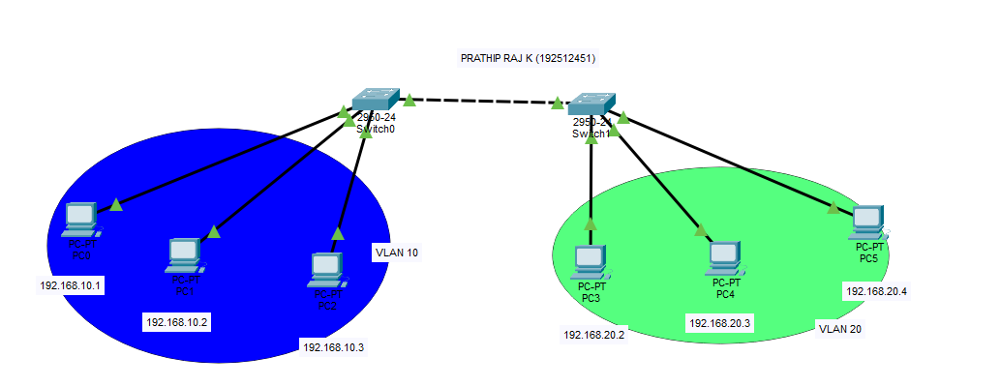
Output:
Objective 1: VLAN Configuration
Sl. No | Source IP | Destination IP | Data sent (bytes) | Data received (bytes)
1 | 192.186.32.2 | 192.186.32.6 | 4 | 4
2 | 192.186.32.3 | 192.186.32.6 | 4 | 4
3 | 192.186.32.4 | 192.186.32.5 | 4 | 4
4 | 192.186.32.5 | 192.186.32.2 | 4 | 4
5 | 192.186.32.6 | 192.186.32.3 | 4 | 4

Result:
Objective 1: VLAN Configuration
The VLANs were successfully configured, and communication was established only between devices within the same VLAN while communication between different VLANs was restricted.

